Online Resource Guide

Below you will find instructions for applications on the iPad. I have also attached login instructions to use for a different device with your child’s login information. Please be sure to check my class website daily for assignments and updates. Assignments will be listed under the homework section.

Application | Subject | Description | Time to Complete
Fast Forword  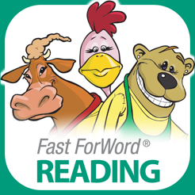 | Reading | Helps build student skills in phonics, comprehension, and fluency. Students have 2-3 assignments per day to complete. | 30 minutes
Kids A-Z | Reading | Students are assigned individual reading levels in the “Level Up” section. Students listen to a text, record themselves reading, and take a comprehension quiz. | Varies depending on individual student level
XtraMath | Math | Helps to build math fluency for addition, subtraction, multiplication, and division. | 10 minutes
ST Math | Math | Visual math program that builds a deep conceptual understanding of math through creative problem solving. | Check daily assignment on class website
IXL | Reading and Math | Reviews important skills taught for reading and math. | Check daily assignment on class website
Flocabulary | All subjects | Educational videos with vocabulary games, quizzes, and more! | Check daily assignments on class website

